

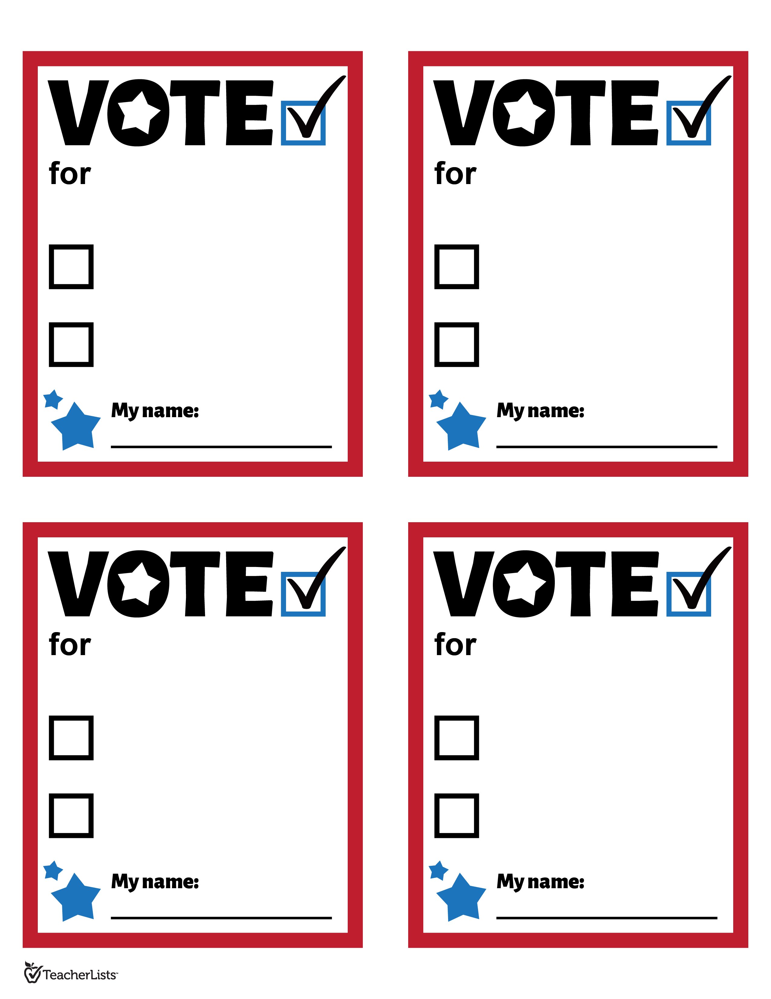­­­­­

**<editable field>**

**<editable field>**

**<editable field>**

**<editable field>**

**<editable field>**

**<editable field>**

**<editable field>**

**<editable field>**

**<editable field>**

**<editable field>**

**<editable field>**

**<editable field>**